**Analysis of survey answers given by students/young adults**

**Statistics - Question 1** 2

*What do you consider to be commonsense knowledge when washing clothes?* 2

**Statistics – Question 2** 4

*What do you consider to be commonsense knowledge when doing dishes?* 4

**Statistics – Question 3** 6

*What do you consider to be commonsense knowledge when vacuuming?* 6

**Statistics – Question 4** 8

*What do you consider to be commonsense knowledge when cooking?* 8

**Statistics – Question 5** 10

*What do you consider to be commonsense knowledge when cleaning windows?* 10

**Average statistics** 12

*Average Gunning Fox Index* 12

# **Statistics - Question 1**

### *What do you consider to be commonsense knowledge when washing clothes?*

Empty all pockets.

The cleaner the better.

Separate you clothes by color, For example: Colored, dark and white separately.

Kleur op kleur. Zwart op zwart. Kleren van binnenuit wassen voor optimaal resultaat.

Het scheiden van verschillende soorten kleding. waspoeder/waspods gebruiken.

wasprogramma selecteren die past bij het wasgoed.

Dat je niet alles bij elkaar gooit maar het verdeeld.

-You need soap.

-Every piece of clothing has a label that tells you how to wash it.

Kleren in de trommel doen, deurtje dicht.

Not too hot, seperate colors from white, use the right type of detergent per specified wash.

Which types of clothes can be washed together, and the functions of different programmes.

Know the different programmes, know how to sort clothes, know the detergents.

Know how the washing machine works.

Know which clothes belong together in the washing machine.

Don't mix colors.

Check the labels for instructions.

Watch out for soft clothes.

Put hoodies/jeans reversed and zipped up.

Check pockets before washing.

1) Seperating colours.

2) using the right temperature.

Wash white with whites only.

Temperature, color, washing liquid.

Separate colored and white clothes, and separate different clothing materials.

Opening door.

welke kleuren je bij elkaar kan wassen en op welke stand en tempratuur je dit moet wassen.

That you need to separate white from colour clothing.

Knowing that you don't wash white and colour together.

Using the washingmachine.

Seperating colors, using detergent.

Use soap.

Let it dry in the sun immediately after you’re done.

In case of washing your clothes with a machine, I think the buttons of how long you want your clothes to be washed and how for example Handwash mode.

Kleur scheiden, bepaalde temperatuur, poeder erin, vergeet je telefoon niet eruit te halen

All the clothes are wet after it's washed.

It will take some time till the clothes are dry.

You have to open the clothes, so it can dry faster.

You have different kind of standards for washing the clothes. For example colourful clothes and white clothes.

Sorting clothes.

Color by color.

Het scheiden van kleuren.

Turn around socks.

Color correct.

Divide between coloured and non-coloured clothes.

Seperating colors and fabrics.

Witte was en gekleurde was apart wassen.

Kleur apart van wit.

how to turn the machine on and off, what program you should use, that black clothes should go together etc.

Watch the labels, colors, temperature and materials.

Just pressing the button and wait till its done.

sorting by colour, clothes having washing / drying instructions on the labels.

-At which temperature you wash specific pieces of clothing.

-Washing colour-organized.

Use the right temperature with the material or clothing type that you are going to wash.

What to wash seperately.

Seperating the whites from the colours.

Set the machine ,hang the clothes,fold them.

Separate white from colour / Where to put softener.

Kleuren scheiden, wasmachine aanzetten.

All the clothes have to be and look clean and have to smell fresh after I washed them.

Wassen.

Degrees and putting white with white only.

Never mix Colors and White.

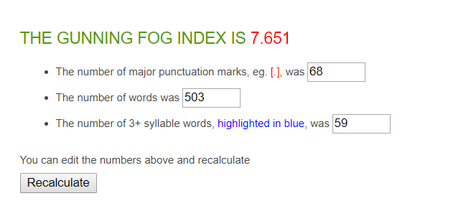

|  |  |
| --- | --- |
| Average Word Length (char) | 5.2 |
| Average Sentence Length (word) | 6.5 |
| Monosyllabic Words (1 syllable) | 263 |
| Polysyllabic Words (≥3 syllables) | 74 |

**77 sentences in total**

**50 answers in total**

**On average: 1.54 sentences per answer, with a sentence length of 6.5 words per sentence.**

# **Statistics – Question 2**

### *What do you consider to be commonsense knowledge when doing dishes?*

Scrub it well, more than once, until clean.

To use cif while doing the dishes and close the tab.

Rinse the dishes, then use soap to clean and finally wash it off. Also use hot/warm water, not cold.

Het gebruik van een spons bij het wassen van de borden, lepels, etc. wanneer men niet gebruik maakt van een vaatwasser.

Spoelen, afwasmiddel zetten op schuurspons, zachte kant schuurspons gebruiken bij objecten die gevoelig zijn voor krassen/indien je geen krassen wilt, drogen met handdoek.

Dat je eerst de spullen afspoelt.

-You need soap, water and a sponge or a dishwasher.

-You clean the dishes using the sponge.

-You might get wet when you use too much water.

Schoonmaken.

Use soap, hot water, dishwash soap.

When using a dishwasher, you should know how the dishwasher functions and which items can be put in the dishwasher.

When doing the dishes without a dishwasher, you should know what type of cleaning product to use.

Using the soap and know how to wash.

Know how the dishwasher works.

being careful with handling them, not scrubbing pans with special coatings, use soap sparingly.

Not using the same sponge you use for washing cutting boards where you cut raw meat for regular utensils.

Use Hot water.

1. Dishes should be wiped dry after washing them.

2. Do not use a hard scrubbing sponge to wash certain dishes.

Opening tap.

hoe je de vaat wast.

In which order you need to wash it.

Use soap .

Use warm water.

Use hot water.

Doing the bigger dishes first, using a clean sponge.

The use of soap and clean both sides.

Where the dishwasher tablet should be put. Whether you wash it by hand or the dishwasher, you need water.

Gebruik zeep, heet water, niet de antiaanbak laag mole.

You can do the dishes by hand and also with a dishwasher.

It will dry when you clean it with a dish towel.

You need soap and water for the dishes, otherwise it will not be clean.

Washing properly.

Use dish soap. Rinse the dishes.

Turn off the water when washing the dishes with soap.

Get the dishes wet.

Use dish soap. Rinse the dirt off with water.

Afwas zo zetten dat het kan opdrogen.

De manier hoe je schoonmaakt en geen domme dingen uithalen.

That you should put soap in, use a brush, then dry it after.

Be careful cause dishes can break fairly easily, dont burn your hands, use soap.

Also press the button on ‘cleaning’.

using soap and some kind of spunge or brush.

Using slightly warm water.

Clean your dishwasher one time a month.

Hot water more effective.

Wash and dry.

Soap.

Use warm water.

Afwasmiddel en een sponsje gebruiken op z'n minst, vaatwasser inruimen.

All the dishes have to be clean and they have to shine.

Borden.

How the machine works.

Use dishwasher.

When to apply different kinds of sponges and how to use water temperature to your advantage.

Hoeveelheid wasmiddel bepalen.

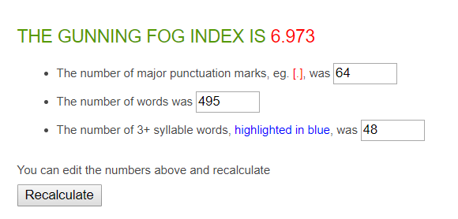

|  |  |
| --- | --- |
| Average Word Length (char) | 4.6 |
| Average Sentence Length (word) | 7.2 |
| Monosyllabic Words (1 syllable) | 307 |
| Polysyllabic Words (≥3 syllables) | 42 |

**69 sentences in total**

**50 answers in total**

**On average: 1.38 sentences per answer, with a sentence length of 7.2 words per sentence.**

# **Statistics – Question 3**

### *What do you consider to be commonsense knowledge when vacuuming?*

Go through everywhere.

To turn on the vacuumer and use electricity.

Put the powercable in the wall outlet. Use the vacuumtool to suck up the dirt. Don't suck things that are too big.

Als je een stofzuiger hebt met meerdere standen kan je de ene stand gebruiken voor bijv. laminaat en de andere voor tapijt.

Kleine voorwerpen die weggezogen kunnen worden eerst verwijderen van de vloer.

Dat je alles stofzuigt ook in de hoeken.

-The vacuum cleaner has to move around in order for you to clean your space.

-The vacuum cleaner sucks all the air in.

-Some small items can be sucked in so you have to be careful with that.

Don’t forget corners, look if you have a full vacuuming bag.

Which different modes of a vacuüm cleaner serve which function, and how to empty a vacuüm cleaner.

How to turn on the vacuum cleaner and how to vacuum efficiently.

Do the whole house.

use the two modes when switching from hard to soft floors, extend the pole to reach difficult spots, always fully extend the power cord, if you have multiple power levels put in on full power for hard floors. don't vacuum wet stuff unless your vacuum can handle it.

Every corner.

Do not vacuum big materials that are on the floor.

Using the device.

hoe je de vloer schoon maakt.

That you need to turn the switch on when you are vacuuming a carpet.

Vaccuum under your bed.

Know how to use it.

Starting at the corners.

Vacuum every corner but do it gently.

That you should shift to the front and the back, everyone vacuums in the same way/pattern I think.

Zuig niet te grote dingen op.

The dust is going away when you are vacuuming.

You have to be careful during vacuuming, cause sometimes it takes the little things with it.

Cleaning.

Also vacuum the part which is not visible dirty.

Hoe de stofzuiger werkt.

Take the corners with you.

dust goes in the vaccuum.

See if there is a vacuum bag inside. Put the plug in. Vacuum the floor.

Eerst alles erom heen dus tafels en banken doen en dan stofzuigen.

How to turn the vacuum cleaner on, how to clean the mess that is on the floor.

Some things are too large to vacuum, for carpets you dont wanna use a brush while for 'flat' surfaces you do want to use it.

only collects dust and small garbage, not suitable for sticky objects, liquids etc.

Don't forget the corners while vacuuming.

To have a bag inside.

Plug the vacuum in .

No soap.

Start with big surfaces and then smaller.

Dat je stekker in stopcontact moet steken voordat je begint.

Heen en weer bewegen met de stofzuigerbuis en uiteinde op de grond.

There have to be no dust, sand or waste on the floor, after I cleaned it.

Keep the machine connected to the hose.

To not hoover any liquids and how to change dirt bags.

Stofzuiger aanzetten, stekker in stopcontact steken.

Alles goed schoon stofzuigen.

How a vacuum works and when to renew the vacuum bag.

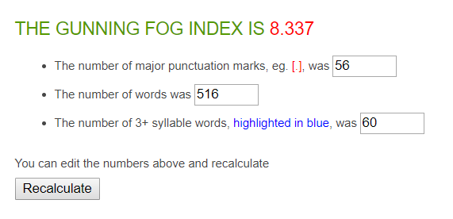

|  |  |
| --- | --- |
| Average Word Length (char) | 4.5 |
| Average Sentence Length (word) | 7.7 |
| Monosyllabic Words (1 syllable) | 327 |
| Polysyllabic Words (≥3 syllables) | 49 |

**67 sentences in total**

**46 answers in total**

**On average: 1.46 sentences per answer, with a sentence length of 7.7 words per sentence.**

# **Statistics – Question 4**

### *What do you consider to be commonsense knowledge when cooking?*

SEASONING (salt and pepper).

Turn on the gas and use oil.

Use oil or some kind of fat to make sure the food doesn't stick to the frying pan. Also wash all your food before cooking.

Bij een gasfornuis: eerst gas open en direct vuur aansteken. Als kip gekookt wordt moet het wel een goeie kleur hebben.

Handen wassen van te voren, schone koomomgeving hebben, veilige kookomgeving hebben.

Dat je steeds test en daarop smaak aanpast.

-Fire is hot so be careful.

-You have to pay attention because you don't want a mess or burn your food.

Eten opwarmen.

Using the rigt type of oils/ingredients.

Some basic knowledge about herbs and spices and with which foods they go well, and also knowing how to put together a nutritious meal (carbs, fats, protein and vitamins and minerals).

Know when and how much oil to use, how much fire you should use.

The time.

Herbs.

Oil.

Pepper and salt.

don't leave spoons etc. in the pans. Use the right amount of heat. Don't leave something one the fire when you're not in the same room. Use a burner not larger than the pan size.

Wash your food before cooking.

Planned out and multitasking.

Basic cooking skills.

1. Do not cook with too much oil, butter, or other sources of fat.

2. Use wooden spoons for certain pans, instead of metal spoons.

Use the pan.

verschillende gerechten kunnen maken.

When something is done you can taste it and you know when it is ready.

Knowing tot salt your water when you're cooking pasta or patatoes.

Clean and tidy.

Prep your meals first.

What ingredients to use. How to prepare it.

How to handle heat. How to make the basics. How to cut food. What kind of knives are for what.

Zwart is niet goed, pas op ui.

When you want to put something in the oven, the oven first has to be heated.

The pan is hot when it is on the stove. You can't touch the pan, while it is on the stove cooking, because it is hot.

Food.

Don’t let the meat be raw.

WAshing ingredients before cooking.

Wash the chicken or meat well.

Use different material when you are preparing meat and vegetables

Heat the pan before using.

Not burn the food. Cook the chicken untill it is free of bacteria’s and germs.

eten niet aanbranden is belangrijkste.

Eerst voorbereiden.

That you should always use oil or butter in a baking pan. That you should put on the extractor hood.

Always cook chicken, and be careful with anything else that's raw. Dont cut yourself. Dont burn yourself. Watch out for expiration dates. Dont use too much salt or other spices.

Know when the meat or chicken is ready and take your time and enjoy cooking.

you need some form of heat, exposing it to heat to long (usually) burns it.

That it is home tutored.

Pick the right ingredients.

Combinations of flavors.

Not burning the food.

Working with a knife.

How long to cook something/ which spices to use / how to separate an egg yolk.

Een recept erbij pakken met uitleg en ingrediëntenlijst. Je hebt potten, pannen nodig en een hittebron.

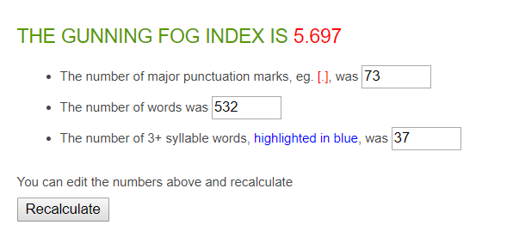

|  |  |
| --- | --- |
| Average Word Length (char) | 4.5 |
| Average Sentence Length (word) | 6.7 |
| Monosyllabic Words (1 syllable) | 350 |
| Polysyllabic Words (≥3 syllables) | 52 |

**80 sentences in total**

**46 answers in total**

**On average: 1.74 sentences per answer, with a sentence length of 6.7 words per sentence.**

# **Statistics – Question 5**

### *What do you consider to be commonsense knowledge when cleaning windows?*

Using detergent.

Use papertowel.

Use some kind of cleaner and a soft towel.

Het gebruik van speciale schoonmaakmiddelen voor de ramen.

Water met zeep mengen om een zeepsop te maken, veilige omgeving met ladder.

Dat je daarna met zo’n zeem het vocht eraf haalt.

-You can use a cloth to clean the windows.

-You can use water with soap.

-You can use Glassex.

Ramen natmaken.

Start at the sides and don’t lift the handle untill you reached another side.

No idea.

Use the right soap and wind cleaner.

also clean window frames.

How to dry.

Also do doors.

start from top to bottom, don't clean them in direct sunlight, watch out for scratches.

Dont wash your windows while the air is dusty.

Hot water.

Ramen droogmaken na schoonmaken.

1. Dry the window off after cleaning it.

2. Use the right towels and sponges.

3. Do not clean windows when it is raining (because this is useless).

The movements.

hoe je een raam schoon maakt.

The Order.

You use water.

Soap.

That thing that looks like a T to het rid of the water and soap.

I dont know.

Starting at the top.

Really get the sides of the window and use warm water.

What kind of products to use. How to actually clean in order to avoid visible lines.

Gebruik zeep.

You need soap and water for cleaning the windows. Also a towel.

Wash first and dry after.

Use water and soap.

Close them.

First use cleanser then wipe off with something dry.

Geen strepen achter laten.

I don't know.

Use soap and the right equipment like those 'rubber brushes' or a good cloth. Always dry well or you might get soap spots after it dries.

use soap and water, wipe the window dry.

Use water with soap to wet the window.

Making smooth motions to avoid leaving lines.

Up to down.

Transparant.

Don't use Sharp objects.

Je hebt een glasreiniger of ander sopje nodig en dat op raam spuiten en iets om het af te nemen.

The windows must be clean so that I can see through them, without seeing any stains.

Don’t use steel wool.

Knowing when to apply glass cleaner.

Van boven naar beneden schoonmaken om strepen te voorkomen.

Manier van schoonvegen, alles naar een kant vegen.

The general practicalities of it.

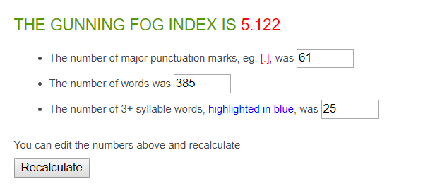

**66 sentences in total**

**46 answers in total**

**On average: 1.43 sentences per answer, with a sentence length of 5.8 words per sentence.**

|  |  |
| --- | --- |
| Average Word Length (char) | 4.5 |
| Average Sentence Length (word) | 5.8 |
| Monosyllabic Words (1 syllable) | 238 |
| Polysyllabic Words (≥3 syllables) | 25 |

# **Average statistics**

### *Average Gunning Fox Index*

(Composed by taking the average of all answers given by students/young adults)

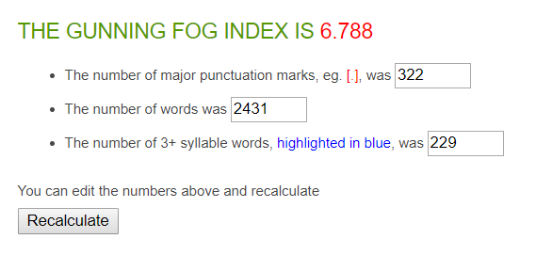

|  |  |
| --- | --- |
| Average Word Length (char) | 4.7 |
| Average Sentence Length (word) | 6.8 |
| Monosyllabic Words (1 syllable) | 1483 |
| Polysyllabic Words (≥3 syllables) | 242 |

**359 sentences in total**

**238 answers in total**

**On average: 1.51 sentences per answer, with a sentence length of 6.8 words per sentence.**